Project Design Phase
Solution Architecture

Date | 17 February 2026
Team ID | LTVIP2026TMIDS90124
Project Name | DocSpot: Seamless Appointment Booking for Health
Maximum Marks | 4 Marks

Solution Architecture:
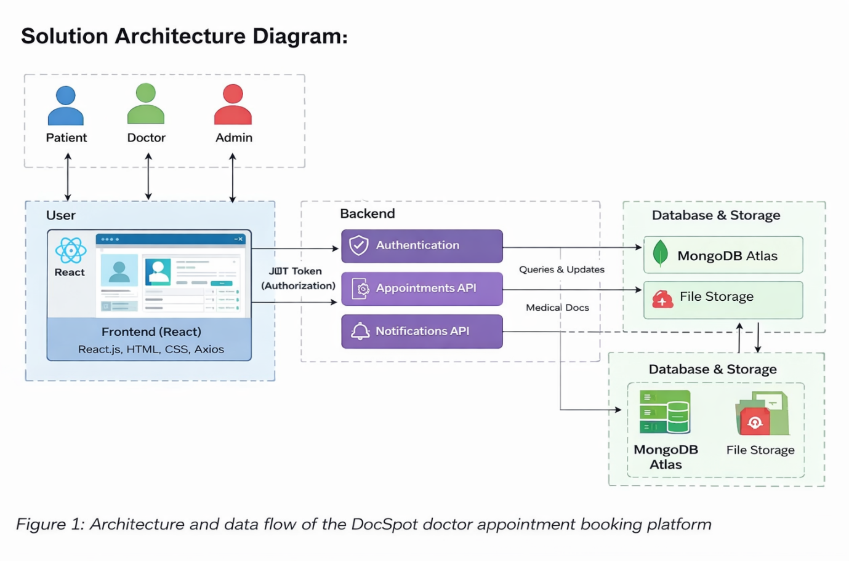
Figure-1: Architecture and data flow of the DocSpot doctor appointment booking platform

